**Assignment 4: User Survey**

Group members: Jonathan Hugo, Kevon Robinson, Anee Patel, Anirudh Palakkal

**Survey Link:** [**https://docs.google.com/forms/d/1QdoO70VL3N8n21wHPL6AZVi65ITesoXJFCMh58vzfqE/edit?ts=5e49a4a8&gxids=7628**](https://docs.google.com/forms/d/1QdoO70VL3N8n21wHPL6AZVi65ITesoXJFCMh58vzfqE/edit?ts=5e49a4a8&gxids=7628)

**Summary added to survey form:**

This survey will be used to assist our group on adding and removing features to an app. The app we plan to make can be used by people to find out the estimated wait time for a restaurant. How it works is that a camera is set up in a restaurant to count the amount of people in a line to estimate wait times. It also takes into account other factors such as current trends (i.e. unicorn frappuccino) or weather conditions.

**Survey questions and results**

* Are you currently attending:

Work

School

Both

Other__

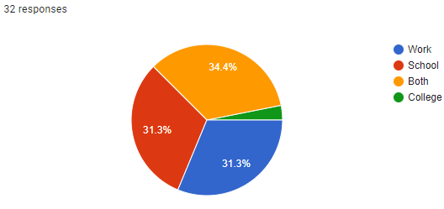

* How satisfied are you with the way you receive estimated wait time in queue?

|  |  |  |  |  |
| --- | --- | --- | --- | --- |
| Not frustrated | Occasionally frustrated | sometimes | Frustrated Most of the time | Angry all the time |

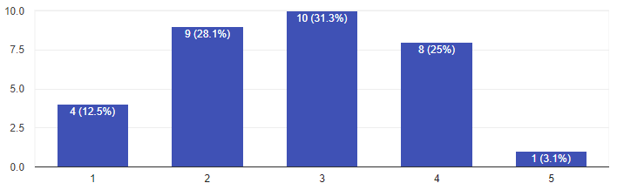

* How often do you bring lunch from home?

|  |  |  |  |  |
| --- | --- | --- | --- | --- |
| never | Occasionally | sometimes | Most of the time | All the time |

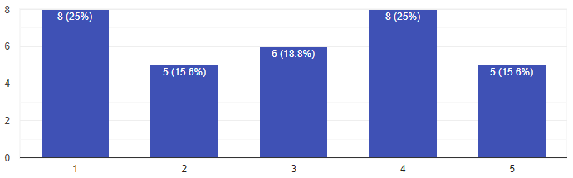

* Have you ever left a restaurant because the queue was too long?
  + Yes
  + No

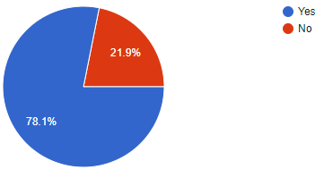

* Do you use the google feature which tells users how busy a store is?

|  |  |  |  |  |
| --- | --- | --- | --- | --- |
| Not frustrated | Occasionally frustrated | sometimes | Frustrated Most of the time | Angry all the time |

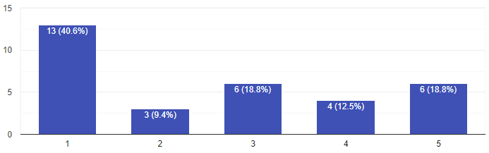

* How frustrated do you get when a line is too long?

|  |  |  |  |  |
| --- | --- | --- | --- | --- |
| Not frustrated | Occasionally frustrated | sometimes | Frustrated Most of the time | Angry all the time |

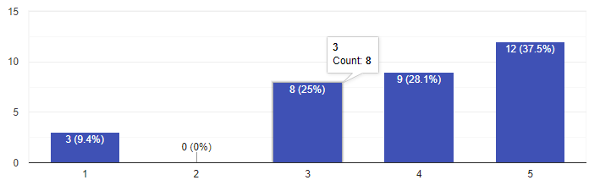

* How do you receive estimated wait times?
  + Trends
  + Being notified by others
  + Other…

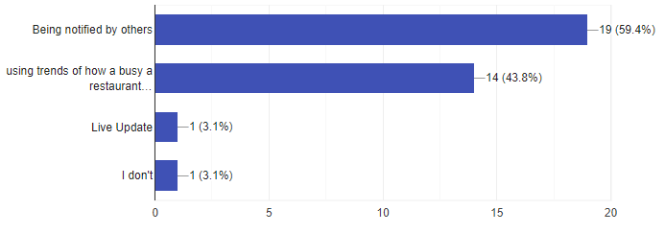

* Do you use weather conditions to determine the length of a queue?

|  |  |  |  |  |
| --- | --- | --- | --- | --- |
| never | Occasionally | sometimes | Most of the time | All the time |

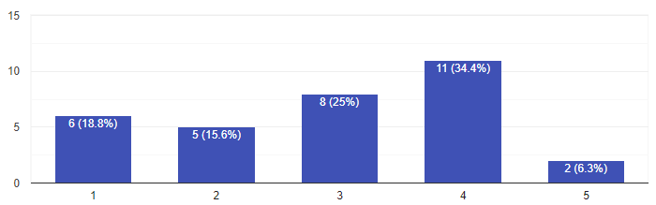

* Which smartphone do you own?

Iphone

Android

Blackberry

Other___

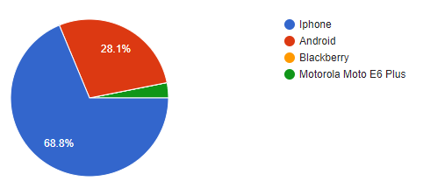

* Would you find it convenient to know the estimated wait time for queues from your smartphone using our application? If so, why?

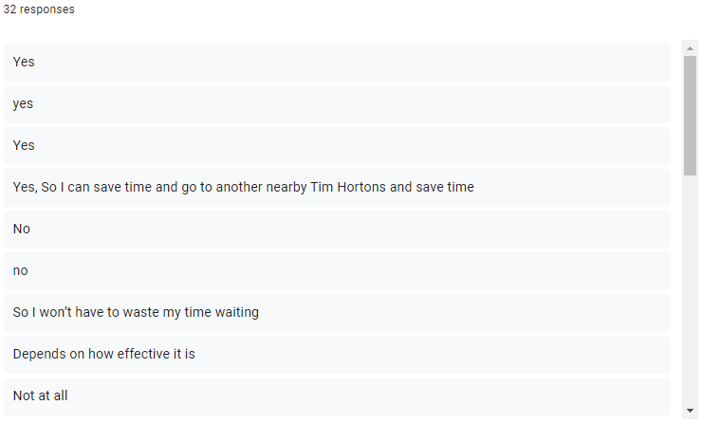

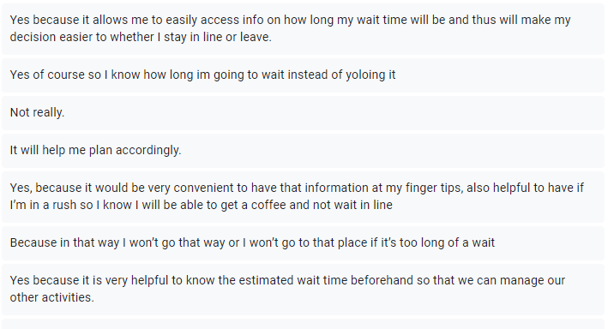

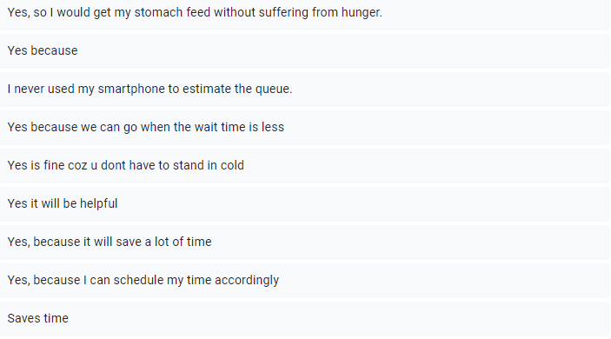

* Would you like to suggest any other features to the app we mentioned at the top of the page?

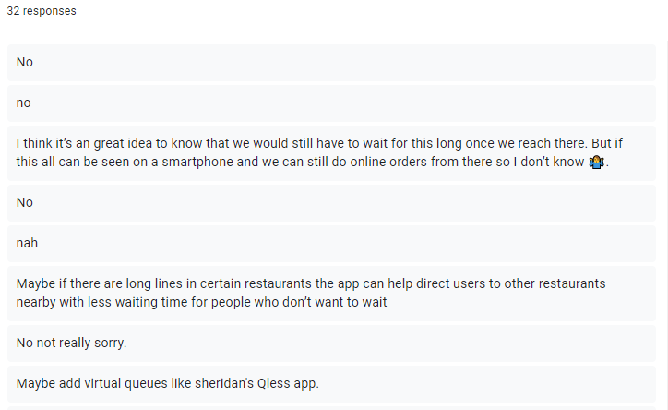

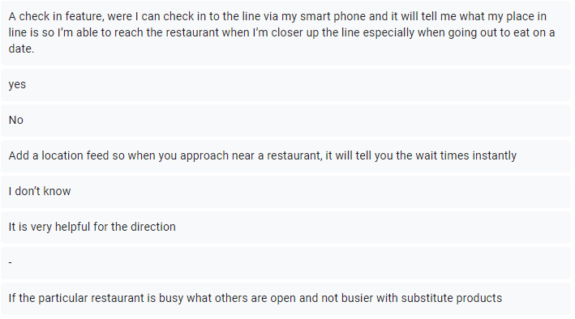

**Analysis of the data**

Features ranked by importance:

1. Get live updates on how long a queue will be.
2. Using trends of past wait times to predict the current wait time.
3. Use weather conditions to predict the wait time in a line.
4. Direct customers to the closest chain restaurant for which the proximity and wait time in line are accounted.
5. Send user to Google maps with directions to the desired location.

Features initially considered:

1. Using trends of wait times to predict current wait time.
2. Get live updates on how long one will be in line.
3. Use weather conditions to predict the wait time in a line.

Since a decent amount of people use

Features not considered:

1. “Maybe add virtual queues like sheridan’s Qless app.”

We wouldn’t necessarily consider this feature completely as many restaurants already implement this in their own app (i.e McDonalds, Tim Hortons, Starbucks, etc) thus it would be difficult to get such companies’ permission to do this as it would make their own applications useless. Otherwise such a feature would be great.

1. “Maybe if there are long lines in certain restaurants the app can help direct users to other restaurants nearby with less waiting time for people who don’t want to wait”

Such a thing sounds annoying as it seems close to just getting advertisements in an app. it would be especially annoying if someone wanted a certain food but then the app starts telling the user of other locations with different types of foods.

Final List of features:(high priority to low)

1. Get live updates on how long a queue will be.
2. Using trends of past wait times to predict the current wait time.
3. Direct customers to the closest chain restaurant for which the proximity and wait time in line are accounted.
4. Send users to Google maps with directions to the desired location.
5. Use weather conditions to predict the wait time in a line.

**User Scenario**



